**Network Analysis lec1**

1. 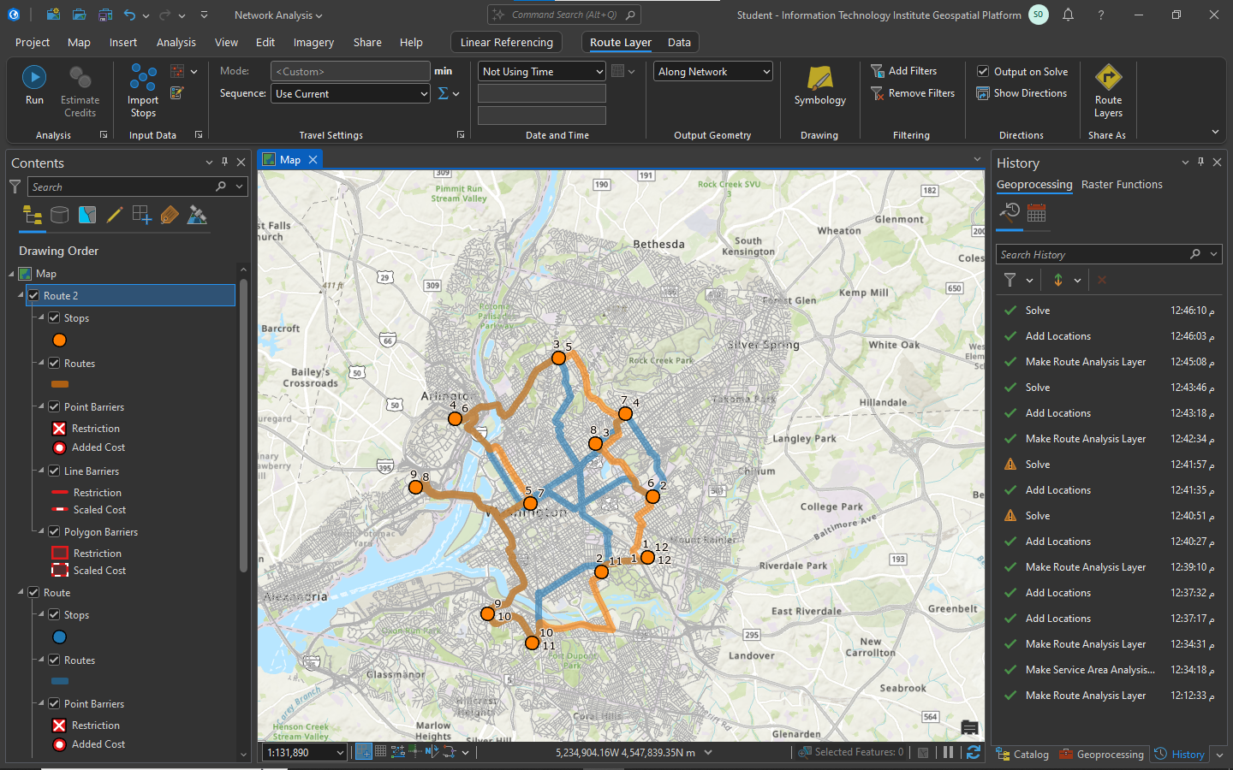Perform network analysis using route solver
2. 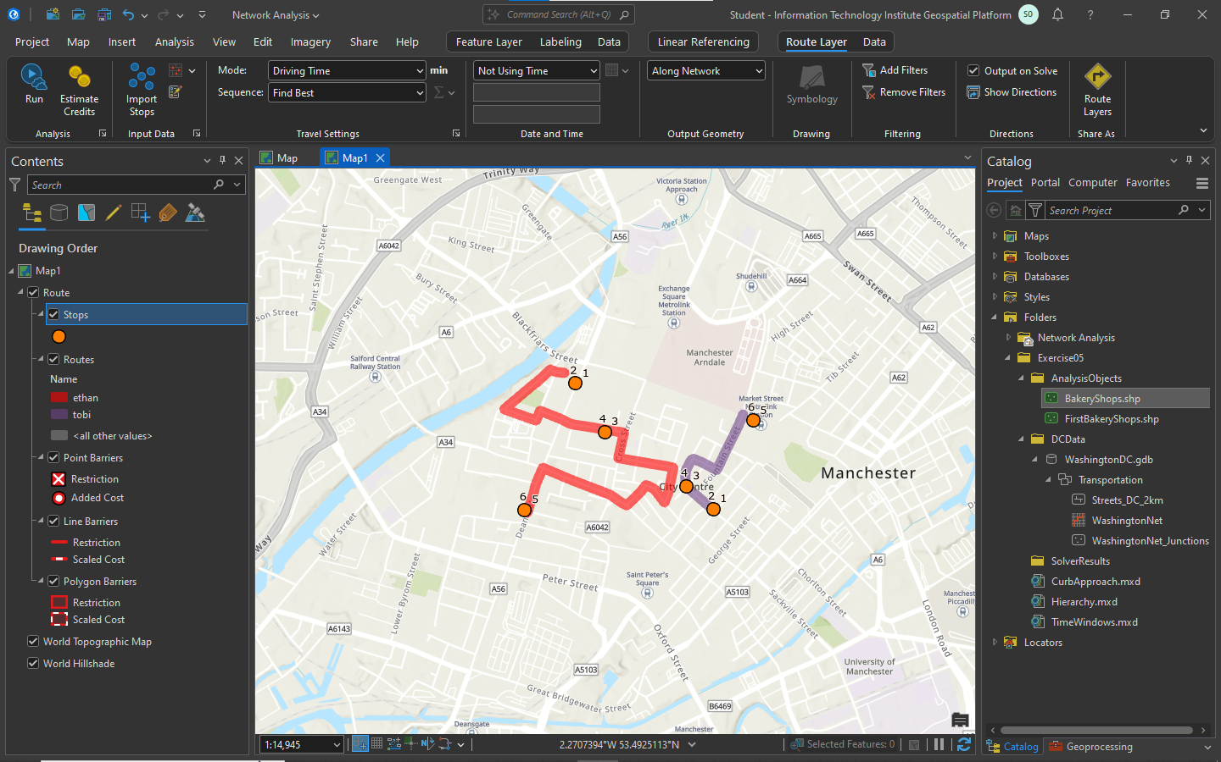2 drivers routes tobi and ethan using route solver
3. 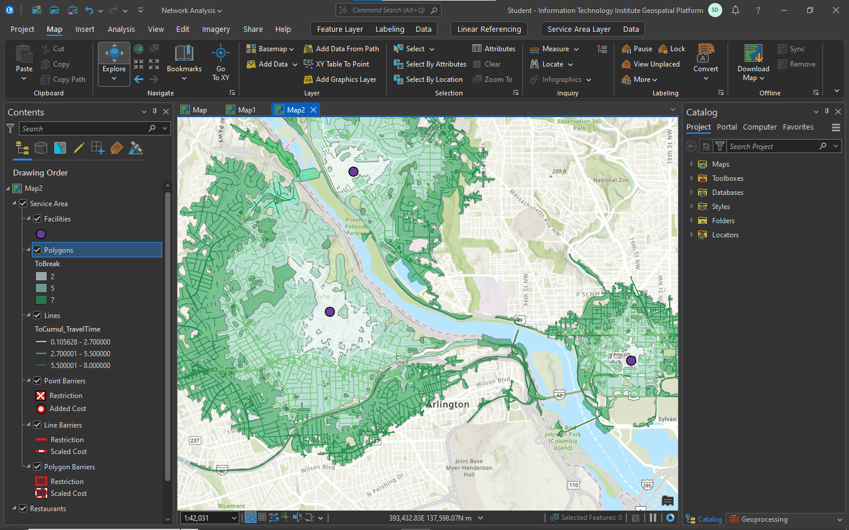Restaurant Using Service area solver